**WEEK-7**

**REACT**

**10. ReactJS-HOL**

**Create a React Application named “officespacerentalapp” which uses React JSX to create elements, attributes and renders DOM to display the page.**

**CODE:**

**Step 1: Create React App**

npx create-react-app officespacerentalapp

cd officespacerentalapp

npm start

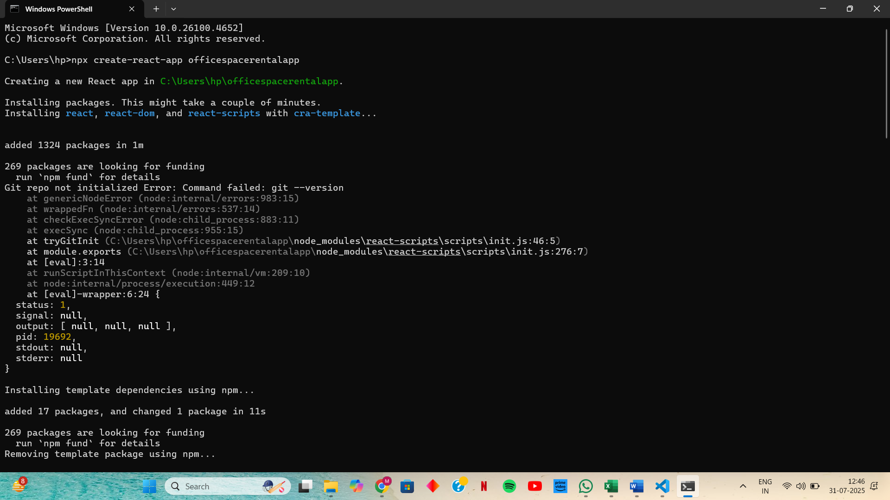

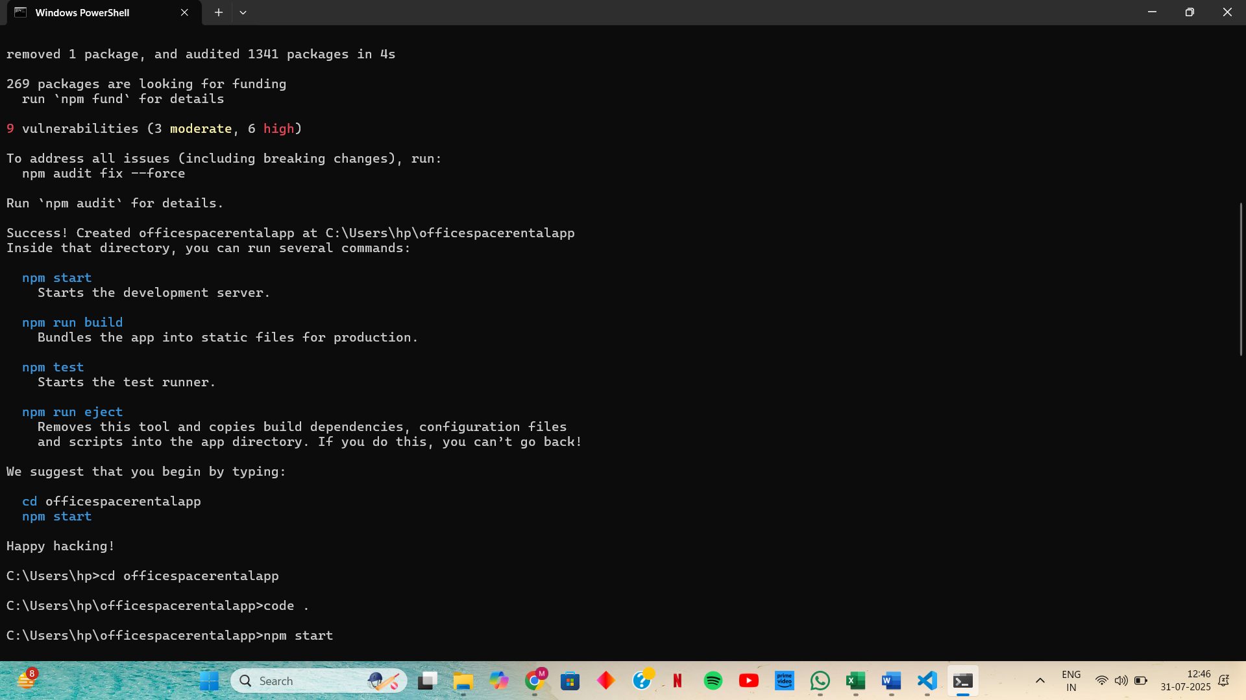

**Step 2: Update Code in src/App.js**

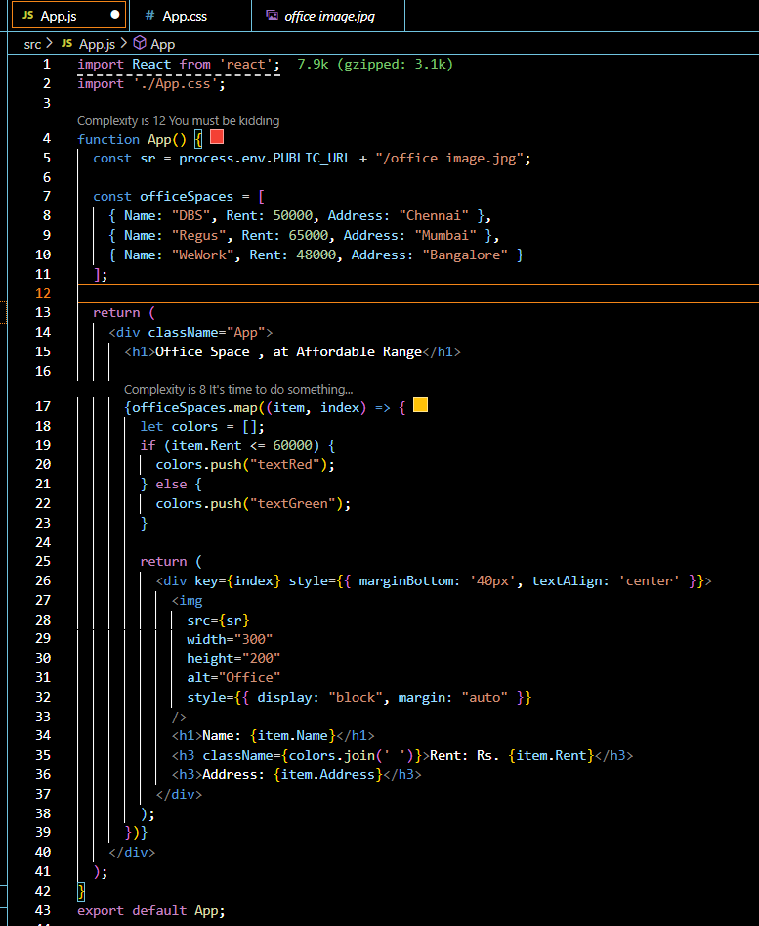

**Step 3: Add CSS in App.css**

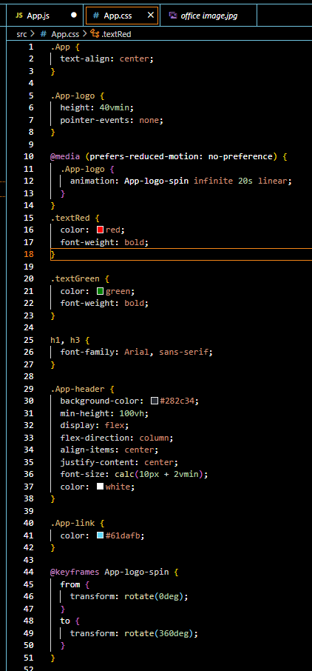

**OUTPUT:**

